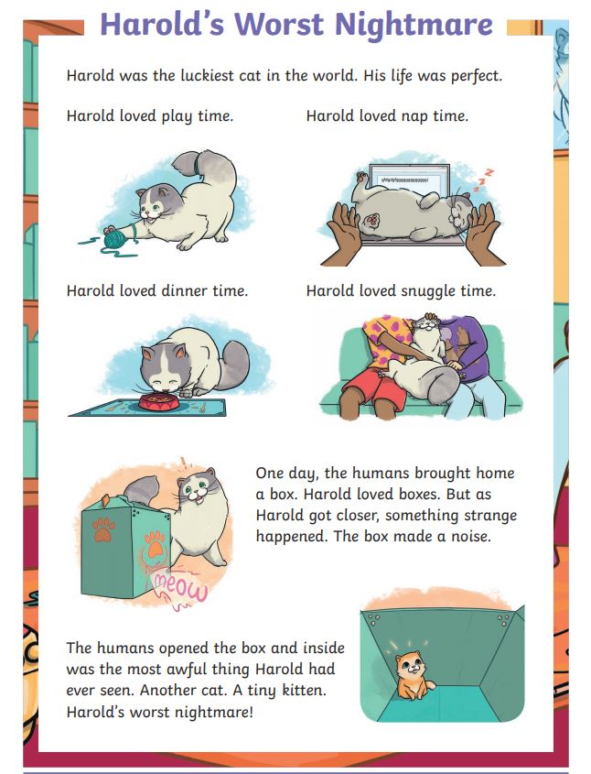
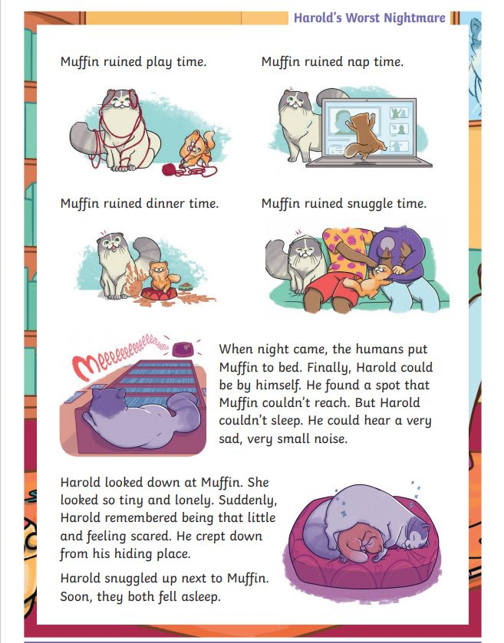
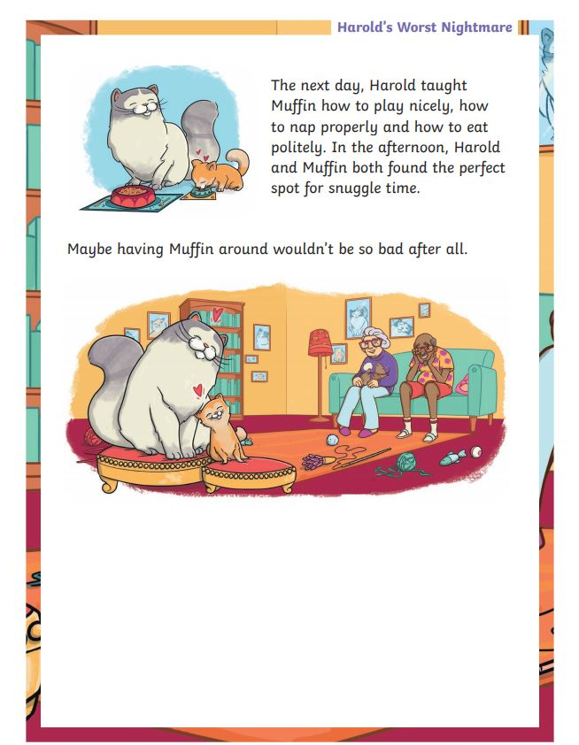

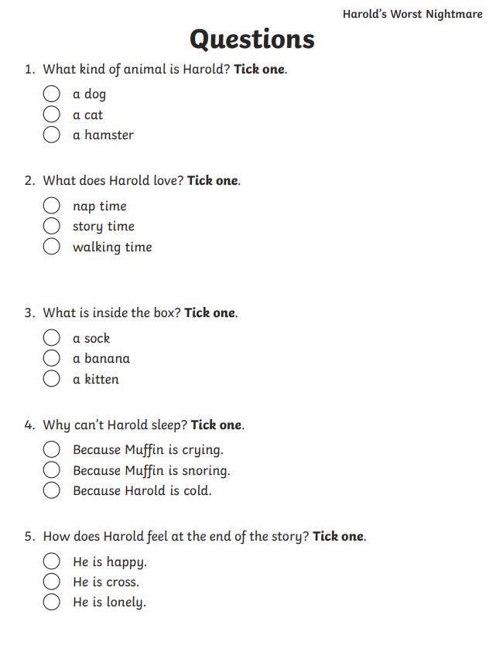

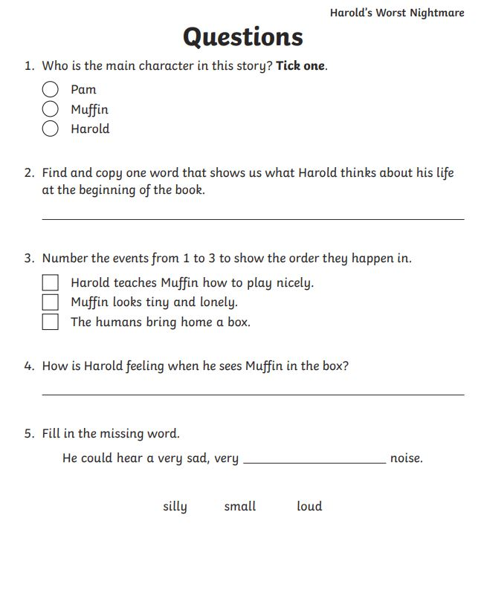
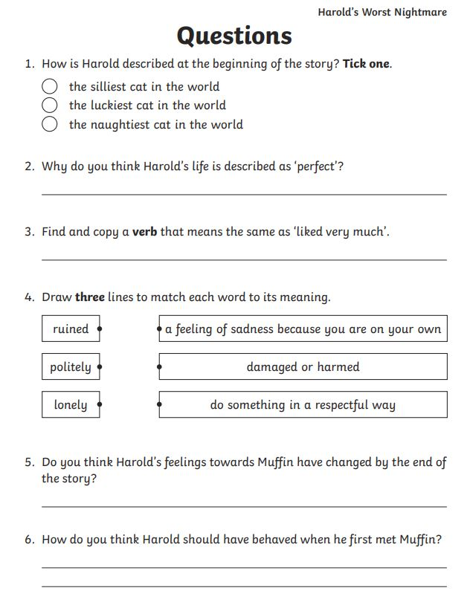
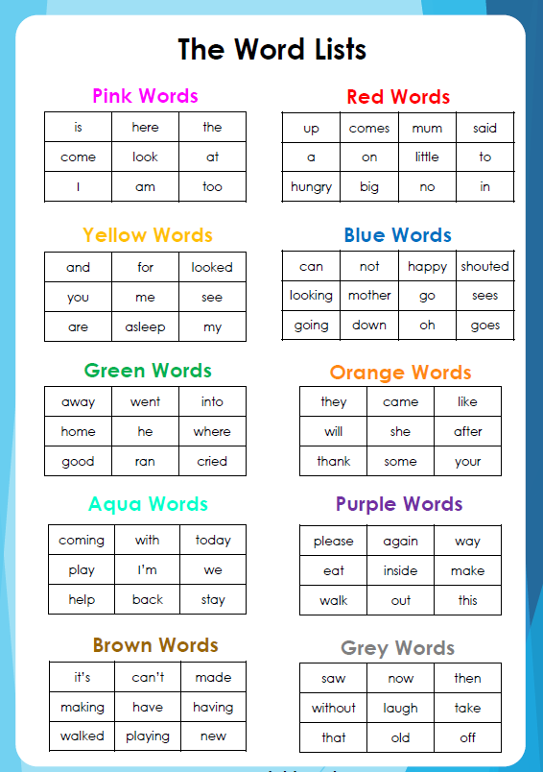

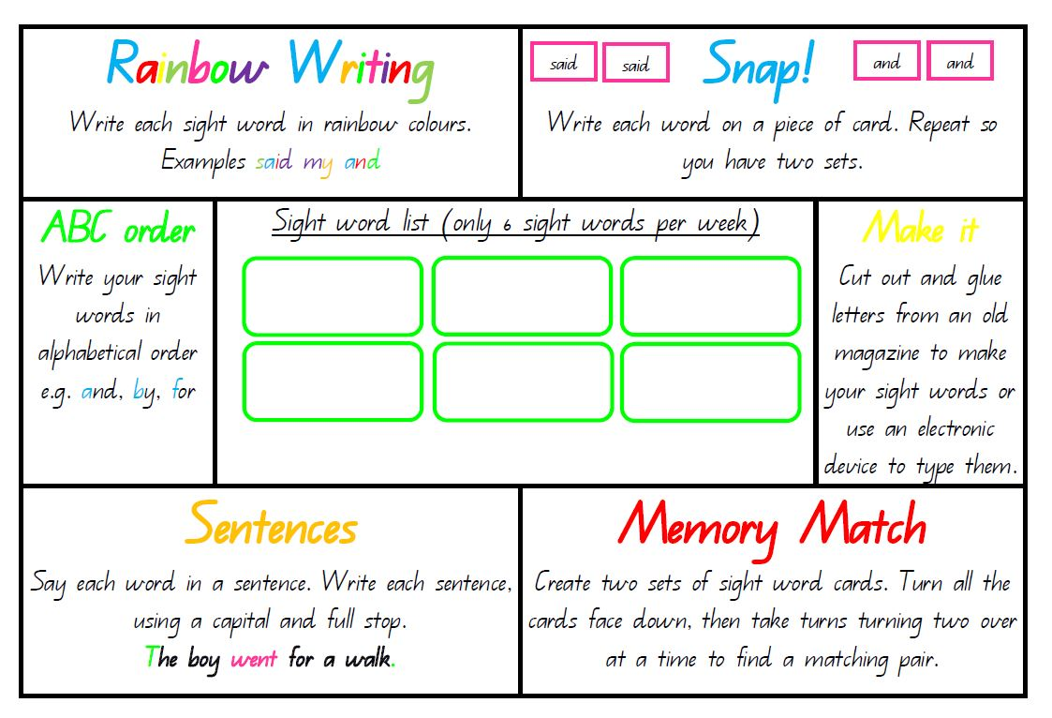
Reading Comprehension
What was the title of the book you read?
_________________________________________
Who was the author?
_________________________________________
Fill out the table below:
 | What happened in the:
 | Beginning | Middle | End
Draw a picture
Write a sentence

What was your favourite part of the book and why?
_____________________________________________
_____________________________________________
_____________________________________________
___________________________________________
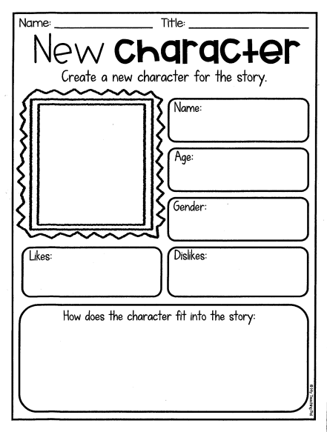
Math
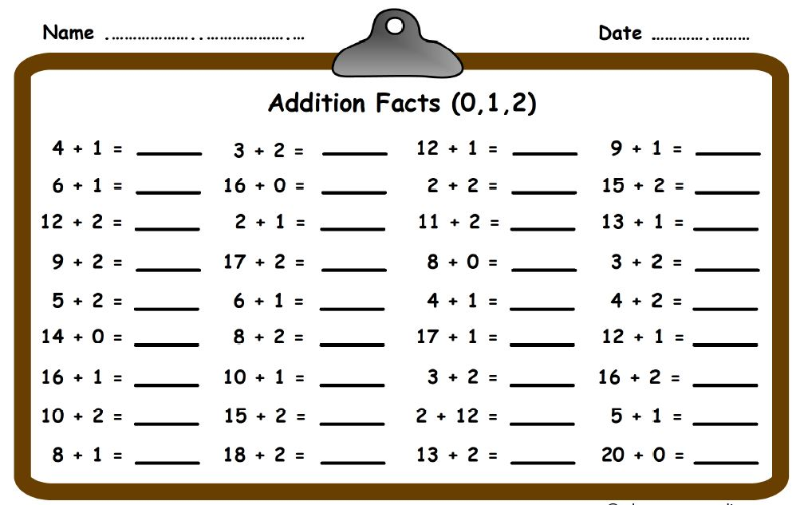
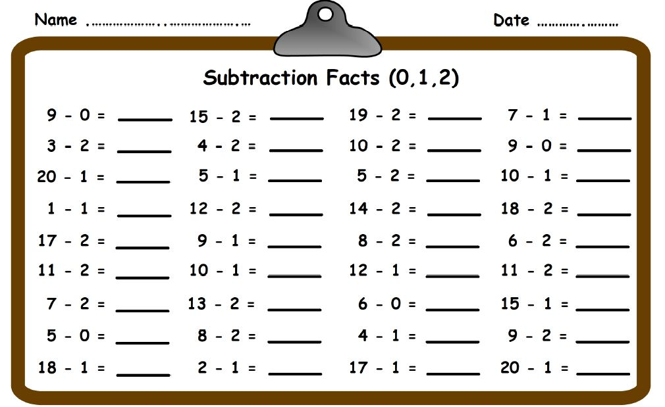
One star – Easy
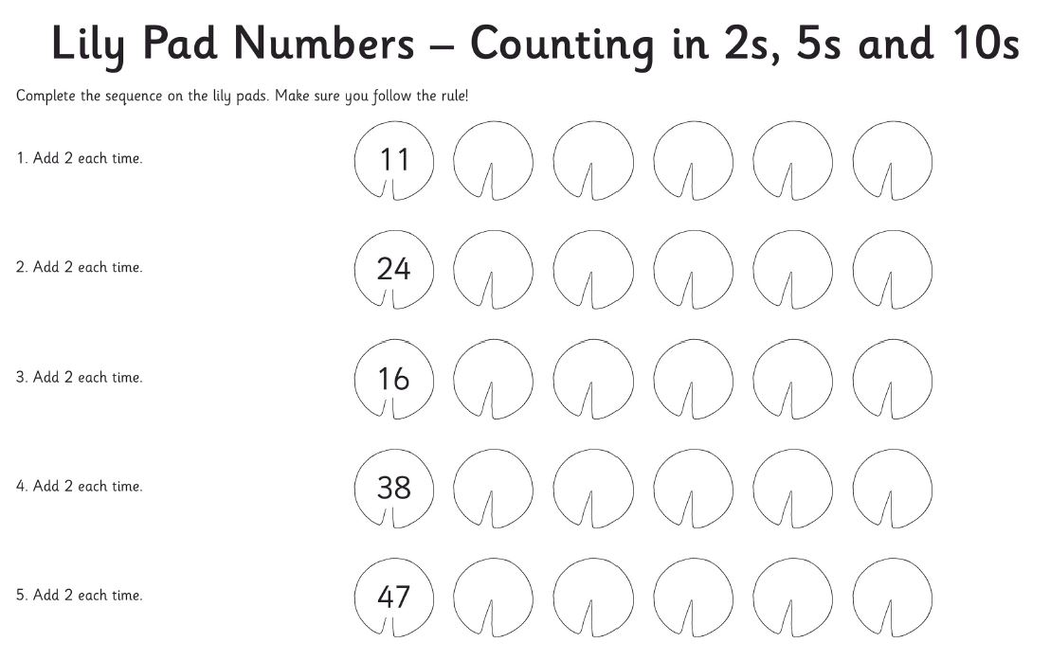
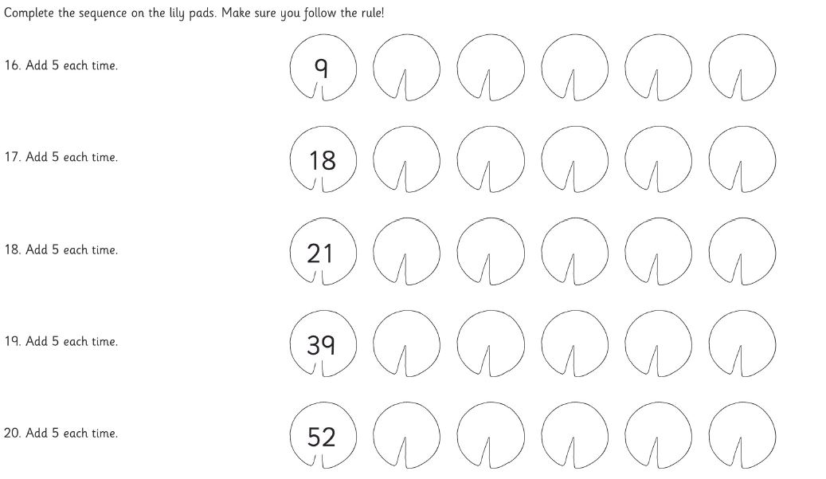

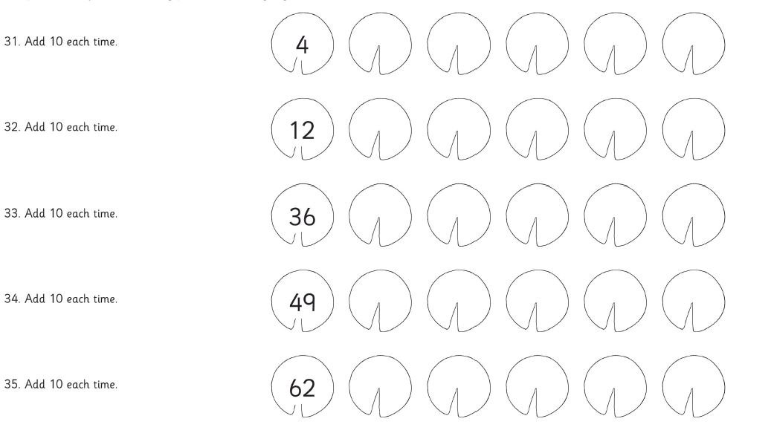
Two star – intermediate
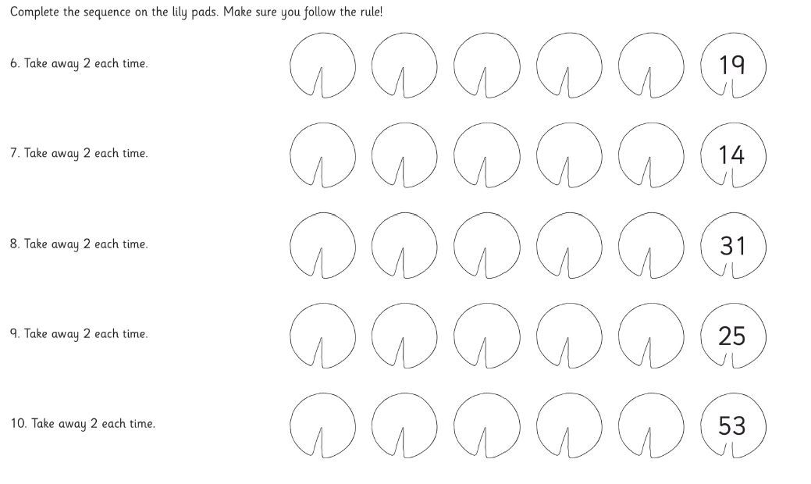
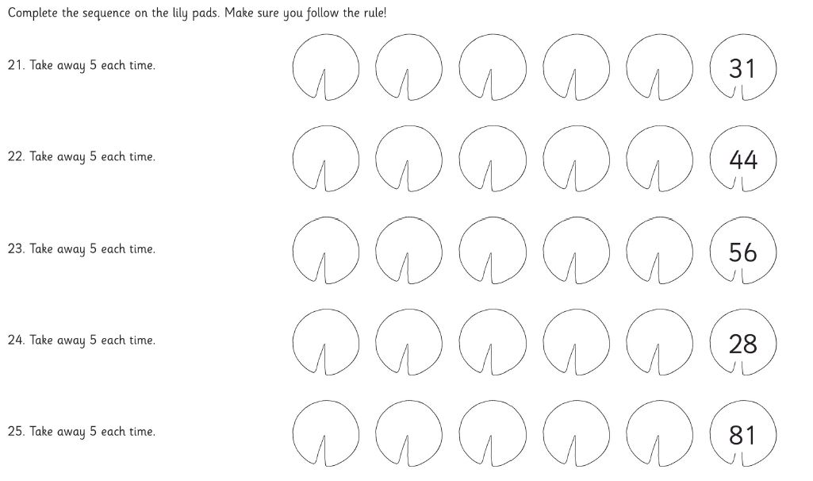
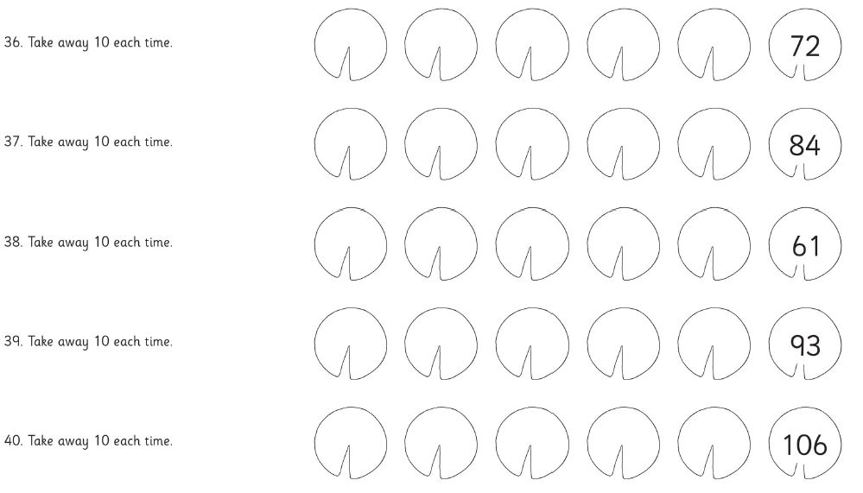

Three star - challenge 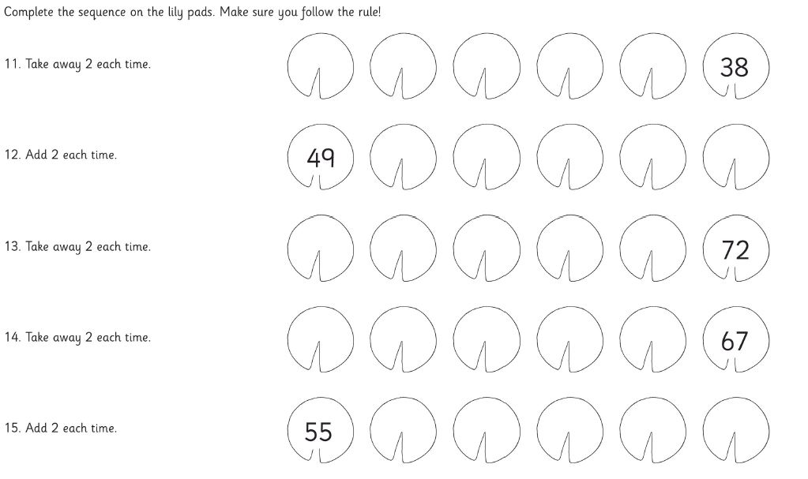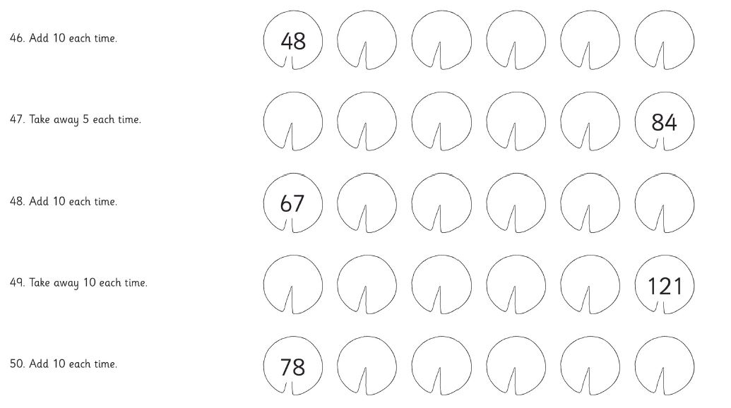
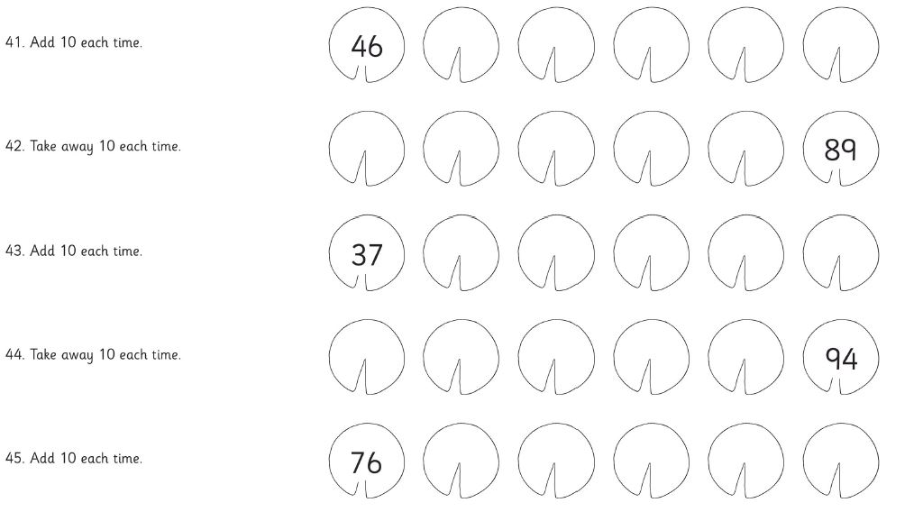
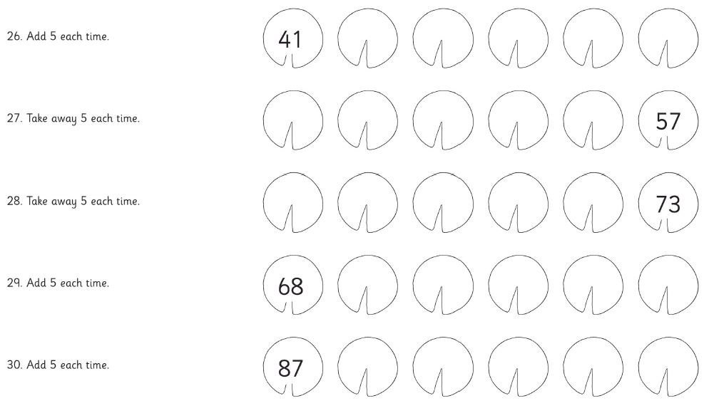
Looking under! Minam Apang
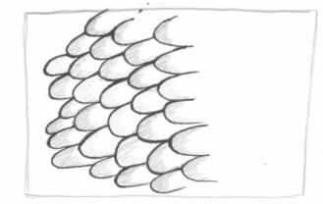 | 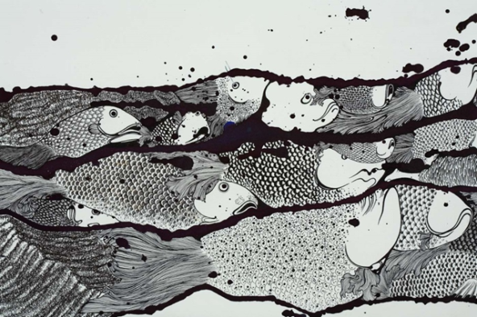  Minam Apang  The sleeping army may stir (detail), 2008  Minam Apang  India b.1980  The sleeping army may stir (detail) 2008  Ink and synthetic polymer paint on fabriano cold-pressed paper 70 x 240cm  Collection : Isabelle Levy and Geraldine Galateau, Paris Courtesy: The artist and Chatterjee & Lal, Mumbai | 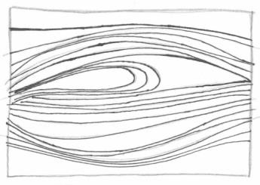
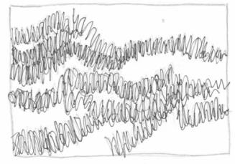 |  | 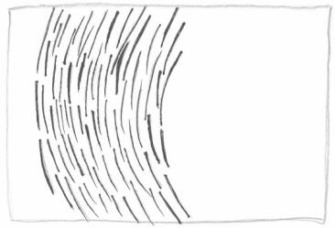
The patterns in the boxes are from this artwork.
Can you find the patterns on the fish?
Draw a line to connect the pattern to where you can see it in the artwork!

Draw a shape or a line and repeat it to create your own patterns.
The more times you repeat the shapes, the more detailed your pattern will be!

These fish are missing their scales!  Create patterns on their bodies. | Add bright colours like fish under the sea.
